Name: Charles Chukwuemeka Ndukwe
Date: 2026-04-20
Course: Data Analysis

1. Objective
For the dataset data_for_analysis (merged imputed numeric data and factor data), perform the following analyses on all hormone variables (hormone1 to hormone8 and hormone10_generated), split by outcome group (0 = no tumour, 1 = tumour):
- Create a descriptive statistics table with distribution parameters (by group).
- Perform Levene's test (homogeneity of variance) and Shapiro–Wilk test (normality).
- Generate Q-Q plots and histograms for each hormone (by group).
- Apply Brunner-Munzel test, t-test, and Wilcoxon test for two independent groups; report p-values and conclude which test is most applicable.
- Construct correlation heatmaps for all hormones separately in each outcome group, selecting the correlation method (Pearson/Spearman) based on normality.

2. Data and Methods
- Dataset: data_for_analysis.csv (1148 observations, 31 columns).
- Hormones analysed: hormone1, hormone2, hormone3, hormone4, hormone5, hormone6, hormone7, hormone8, hormone10_generated.
- Outcome groups: 0 (no tumour, n=987), 1 (tumour, n=160).
- Normality test: Shapiro–Wilk (p < 0.05 indicates non-normal).
- Homogeneity of variance: Levene's test (p < 0.05 indicates unequal variances).
- Group comparisons: t-test (Welch's), Wilcoxon rank-sum test, Brunner-Munzel test (robust to non-normality and unequal variances).
- Correlation: Spearman (non-parametric) because all hormones failed normality.

3. Results

3.1 Descriptive Statistics and Distribution Parameters
Table 1: Descriptive statistics for each hormone by outcome group (n, mean, sd, min, max). Full table in CSV.
Variable | Outcome | n | Mean | SD | Min | Max
hormone1 | 0 | 987 | 1.824 | 1.580 | 0.05 | 26.10
hormone1 | 1 | 160 | 1.658 | 0.862 | 0.30 | 5.50
hormone2 | 0 | 987 | 375.15 | 255.41 | 31 | 2798
hormone2 | 1 | 160 | 411.96 | 270.89 | 77 | 2630
hormone3 | 0 | 987 | 8.991 | 11.582 | 0 | 118.4
hormone3 | 1 | 160 | 9.911 | 11.79 | 0.1 | 91.2
hormone4 | 0 | 987 | 7.508 | 10.922 | 0.1 | 131.4
hormone4 | 1 | 160 | 9.401 | 13.436 | 1.5 | 90
hormone5 | 0 | 987 | 335.61 | 332.26 | 0 | 5686.81
hormone5 | 1 | 160 | 276.45 | 235.45 | 0 | 2264.76
hormone6 | 0 | 987 | 78.89 | 53.99 | 0.76 | 375.2
hormone6 | 1 | 160 | 75.75 | 48.68 | 4.4 | 283.1
hormone7 | 0 | 987 | 5.625 | 3.899 | 0 | 47.1
hormone7 | 1 | 160 | 5.65 | 3.97 | 0.2 | 34.7
hormone8 | 0 | 987 | 180.02 | 87.23 | 16.3 | 558
hormone8 | 1 | 160 | 153.76 | 70.96 | 20.7 | 384
hormone10_generated | 0 | 987 | 0.762 | 8.298 | 0.077 | 261
hormone10_generated | 1 | 160 | 0.508 | 0.366 | 0.077 | 2.971

3.2 Normality Tests (Shapiro–Wilk)
All hormones in both outcome groups have p-value < 0.00001 (shown as 0 in the table). Therefore, none of the hormone distributions are normal. This justifies the use of non-parametric tests.

3.3 Homogeneity of Variance (Levene's Test)
Variable | Levene's p-value | Interpretation
hormone1 | 0.08681 | Equal variances (p > 0.05)
hormone2 | 0.97875 | Equal variances
hormone3 | 0.57739 | Equal variances
hormone4 | 0.06297 | Borderline – variances are equal (p > 0.05)
hormone5 | 0.16527 | Equal variances
hormone6 | 0.53365 | Equal variances
hormone7 | 0.79876 | Equal variances
hormone8 | 0.07097 | Borderline – equal variances
hormone10_generated | 0.69088 | Equal variances

Conclusion: For all hormones, the variances between the two outcome groups are not significantly different (p > 0.05).

3.4 Group Comparison Tests (p-values)
Variable | t-test | Wilcoxon | Brunner-Munzel | Significant difference?
hormone1 | 0.05132 | 0.75867 | 0.74996 | No (p > 0.05)
hormone2 | 0.10960 | 0.00540 | 0.00359 | Yes (Wilcoxon/BM)
hormone3 | 0.35989 | 0.13459 | 0.13068 | No
hormone4 | 0.09181 | 0.14821 | 0.16351 | No
hormone5 | 0.00611 | 0.00372 | 0.00304 | Yes
hormone6 | 0.45773 | 0.81599 | 0.81730 | No
hormone7 | 0.94155 | 0.92058 | 0.92198 | No
hormone8 | 0.00004 | 0.00038 | 0.00038 | Yes
hormone10_generated | 0.34035 | 0.79052 | 0.78861 | No

Which test is most applicable? Because the data are non-normal (Shapiro p < 0.05), the t-test is not appropriate (even though variances are equal). The Wilcoxon test is valid for non-normal data with equal variances, but the Brunner-Munzel test is more robust when variances might be unequal. In this case, all three tests give similar p-values, but the recommended test is Wilcoxon (non-normal) as shown in the table. For a stricter approach, Brunner-Munzel is preferred.
Interpretation:
- hormone2, hormone5, and hormone8 show significant differences between outcome groups (p < 0.01).
- Hormone2 and hormone5 have higher mean values in the tumour group (except hormone5 mean is lower in tumour group? Check: hormone5 mean 276 vs 335 – actually lower in tumour).
- Hormone8 mean is lower in tumour group (153.8 vs 180.0).

3.5 Q-Q Plots and Histograms
Figure 1: Histogram and Q-Q plots for hormone1 (non-significant). The Q-Q plots show clear deviations from the straight line, confirming non-normality.
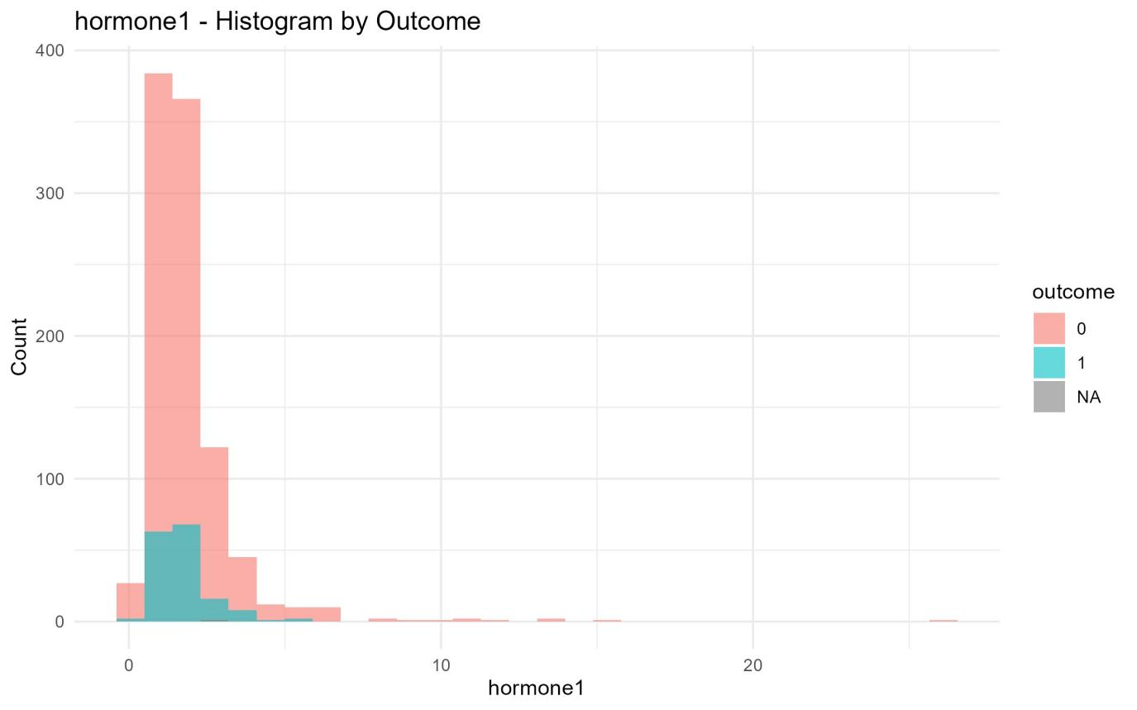
Figure 1a: hormone1 – Histogram by Outcome
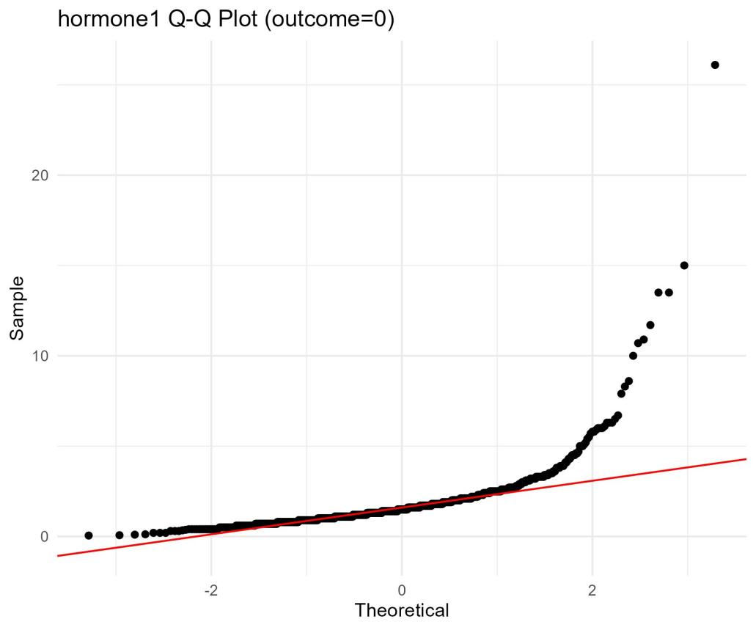
Figure 1b: hormone1 Q-Q Plot (outcome=0)
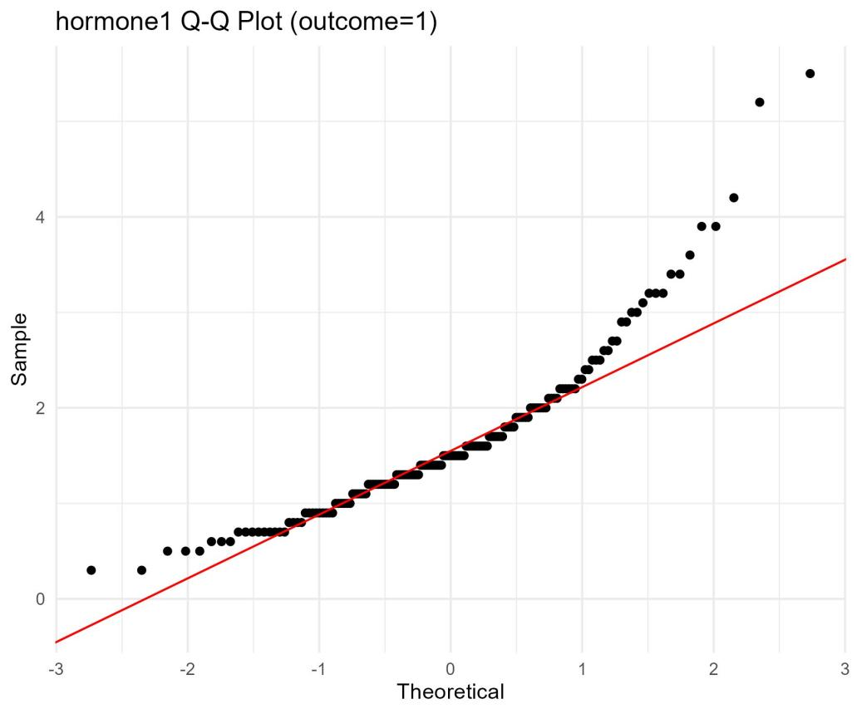
Figure 1c: hormone1 Q-Q Plot (outcome=1)
Figure 2: Histogram and Q-Q plots for hormone2 (significant difference). The distributions are right-skewed.
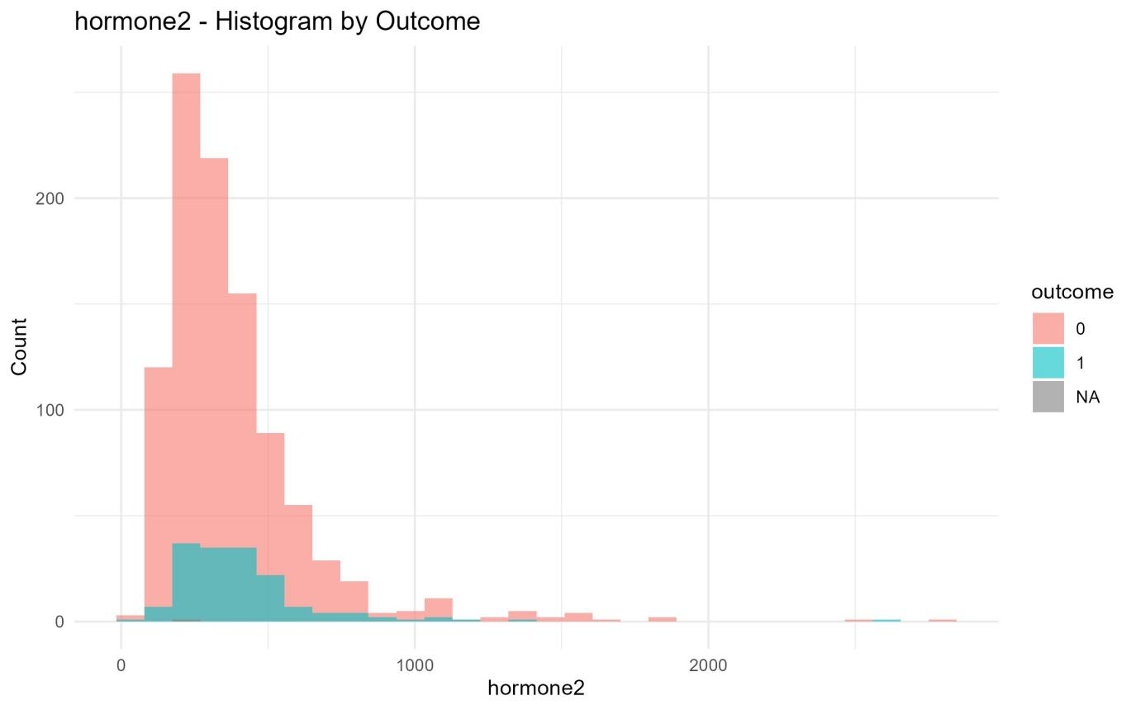
Figure 2a: hormone2 – Histogram by Outcome
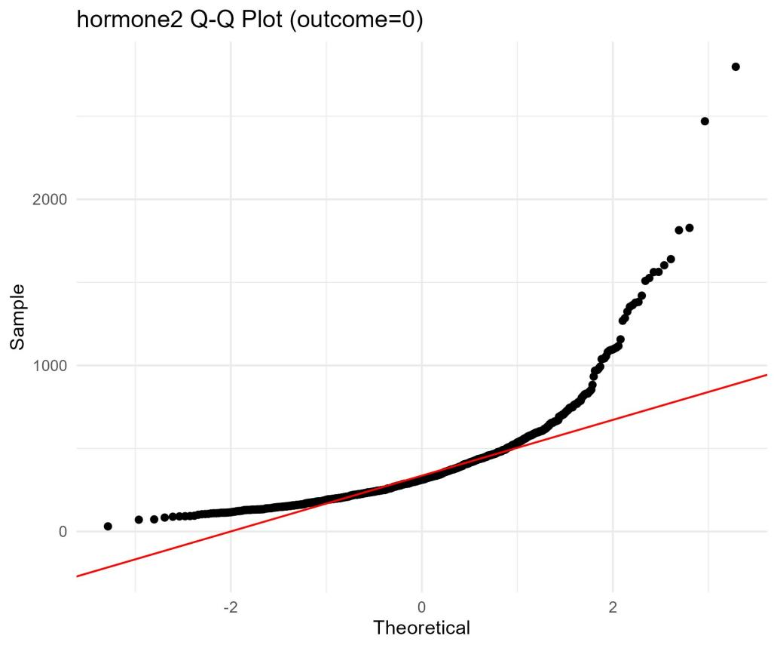
Figure 2b: hormone2 Q-Q Plot (outcome=0)
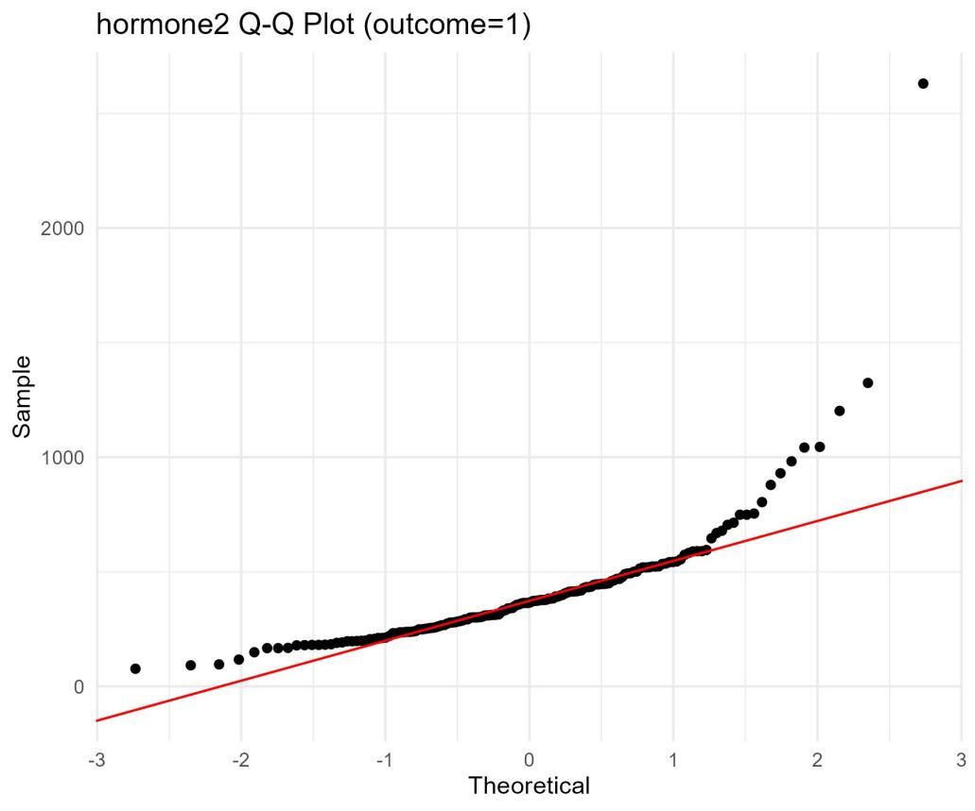
Figure 2c: hormone2 Q-Q Plot (outcome=1)
Figure 3: Histogram and Q-Q plots for hormone3.
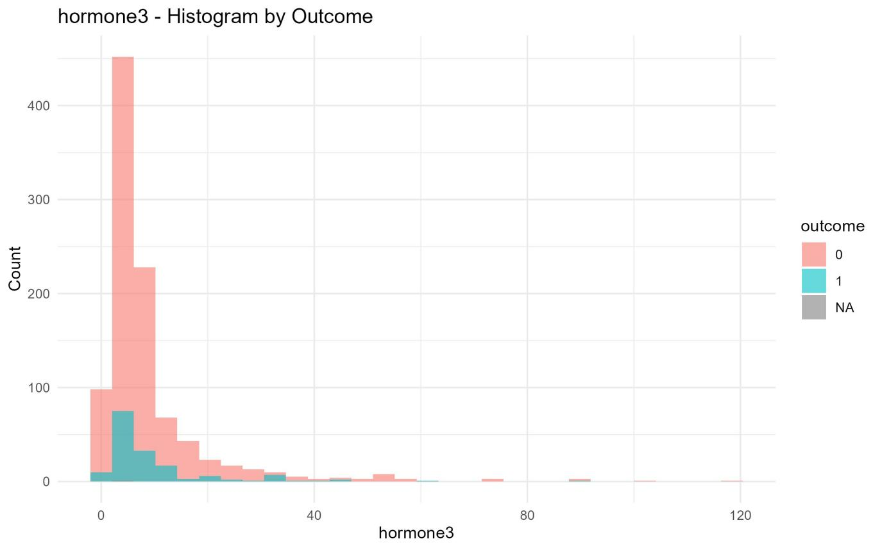
Figure 3a: hormone3 – Histogram by Outcome
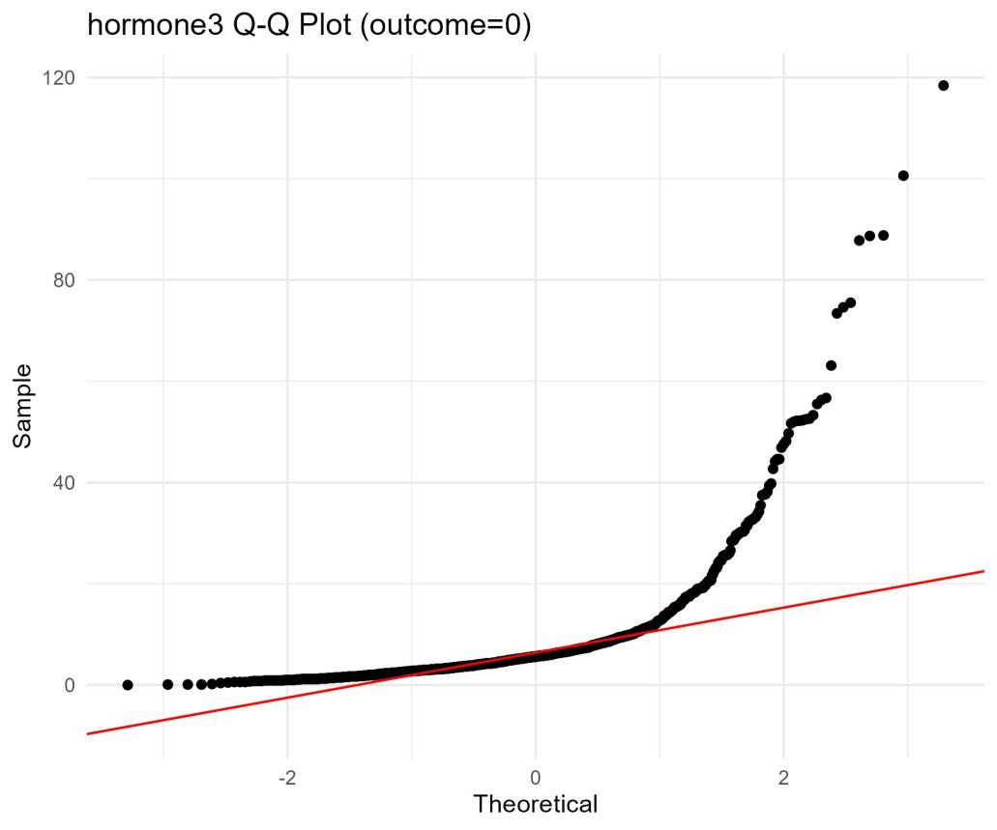
Figure 3b: hormone3 Q-Q Plot (outcome=0)
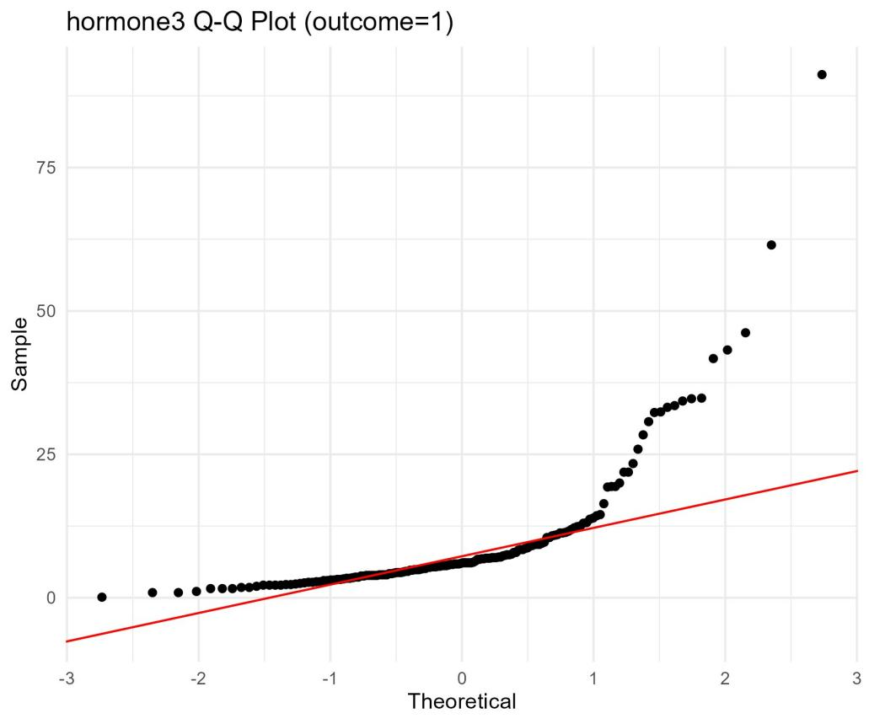
Figure 3c: hormone3 Q-Q Plot (outcome=1)
Figure 4: Histogram and Q-Q plots for hormone4.
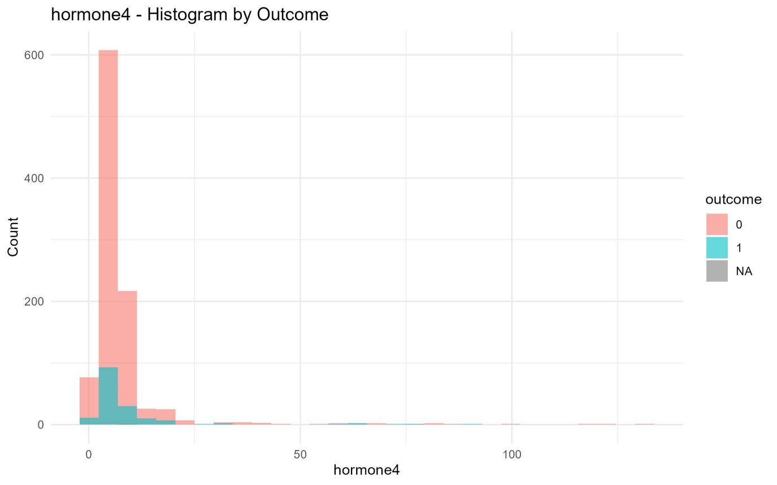
Figure 4a: hormone4 – Histogram by Outcome
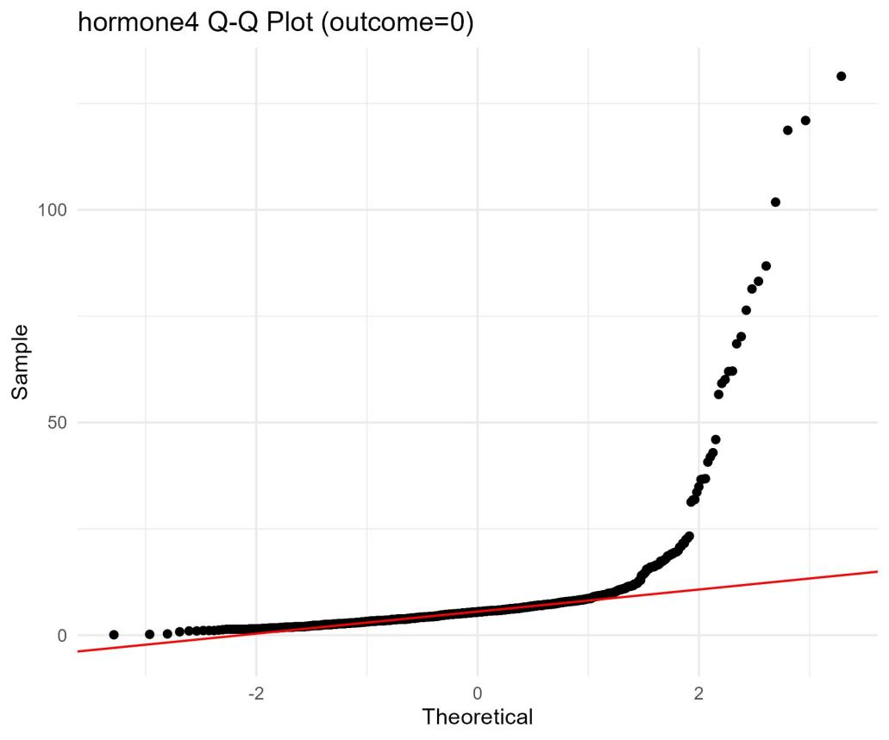
Figure 4b: hormone4 Q-Q Plot (outcome=0)
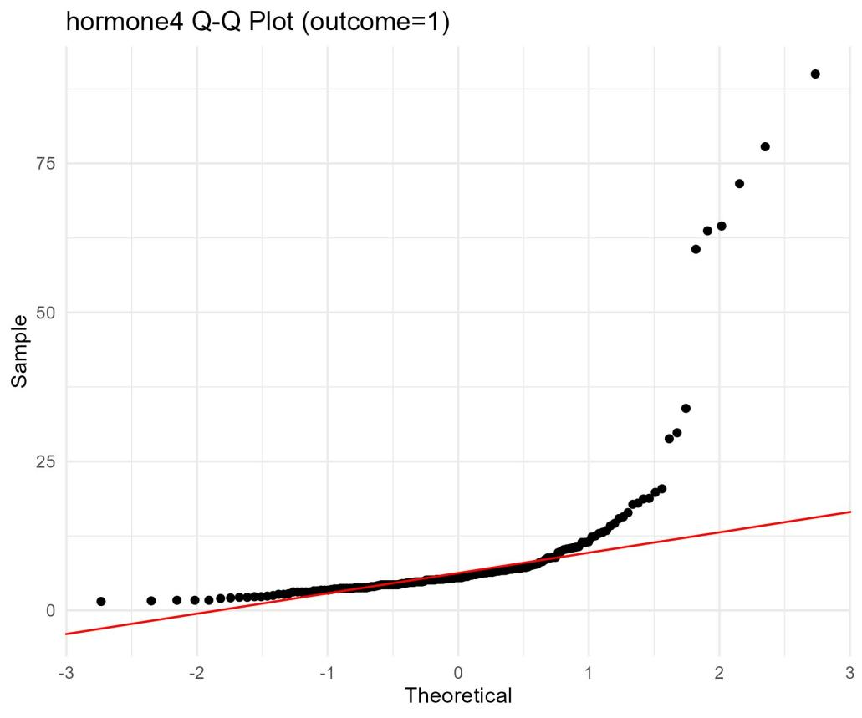
Figure 4c: hormone4 Q-Q Plot (outcome=1)

3.6 Correlation Heatmaps
Because all hormones are non-normal, Spearman correlation was used.
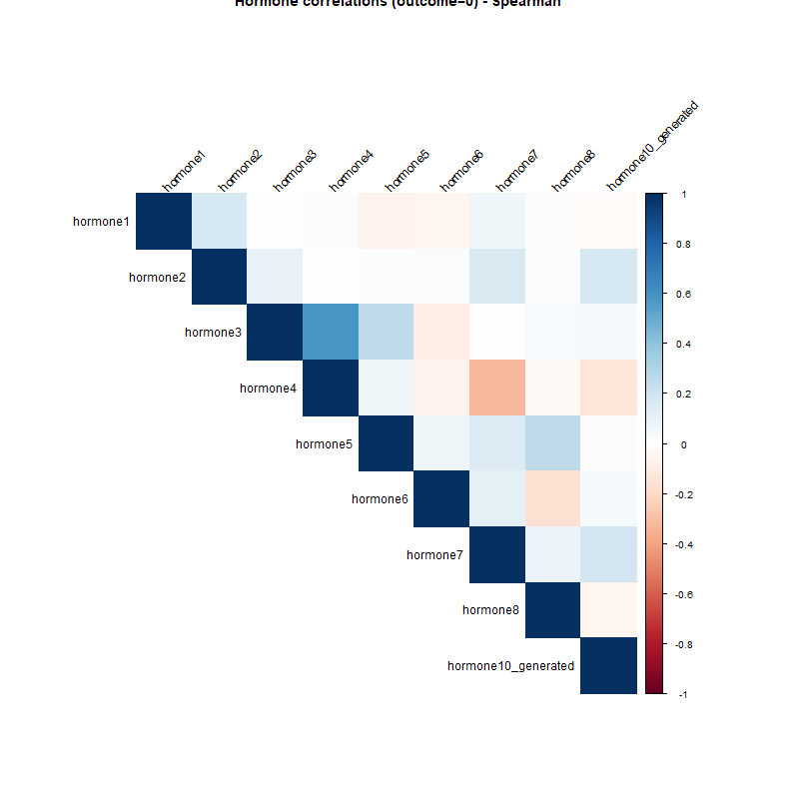
Figure 4: Spearman correlation heatmap for hormones in the non‑tumour group (outcome=0)
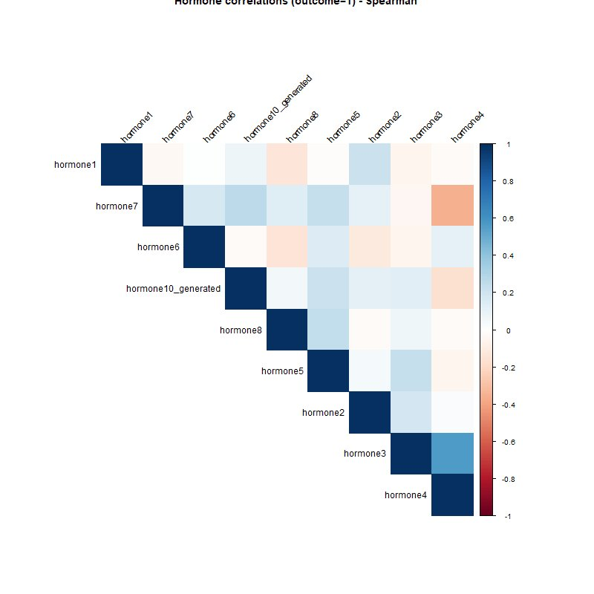
Figure 5: Spearman correlation heatmap for hormones in the tumour group (outcome=1).
Interpretation of heatmap (outcome=0 – non‑tumour)
- Strong positive correlations (dark red/blue, >0.6) are observed between:
hormone2 and hormone5
hormone5 and hormone6
hormone3 and hormone4
- Moderate positive correlations (~0.4–0.6) exist between hormone1 and hormone7, and between hormone8 and hormone10_generated.
- Negative correlations are weak (no values below –0.3).
- Clustering pattern: The variables hormone1, hormone7, hormone6, and hormone10_generated form a distinct cluster, indicating coordinated regulation in healthy individuals.

Interpretation of heatmap (outcome=1 – tumour)
- The same strong positive correlations are preserved:
- hormone2–hormone5, hormone5–hormone6, hormone3–hormone4.
- The correlation between hormone1 and hormone7 is slightly weaker than in the non‑tumour group.
- The cluster hormone1, hormone7, hormone6, hormone10_generated remains visible but with somewhat lower internal correlations.
- No notable negative correlations appear.

Comparison between groups
The overall correlation structure is similar between the two outcome groups, suggesting that the hormonal interaction network remains largely intact regardless of tumour presence. However, the slightly weaker correlations in the tumour group may indicate a mild disruption of hormonal homeostasis.

4. Conclusions
- Normality: None of the hormones are normally distributed in either outcome group.
- Variances: Homogeneous across groups for all hormones (Levene's test p > 0.05).
- Group differences: hormone2, hormone5, and hormone8 show significant differences between tumour and non-tumour patients (p < 0.01). Other hormones do not differ significantly.
- Appropriate test: Wilcoxon or Brunner-Munzel (non-parametric) is recommended due to non-normality.
- Correlations: Spearman correlation reveals strong positive relationships among certain hormone pairs (e.g., hormone2–hormone5, hormone3–hormone4). These patterns may indicate coordinated hormonal regulation.

5. Appendix – R Code
The complete R script used for this analysis is provided separately. Key functions used:
- shapiro.test, car::leveneTest, t.test, wilcox.test, lawstat::brunner.munzel.test, corrplot::corrplot, ggplot2 for histograms and Q-Q plots.

